Name: _____________________________________________________________
Class: ______________________________________________________________
Date: ______________________________________________________________
Home Technology Survey
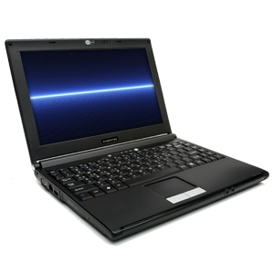

- Directions: Check off the statements that apply to you below.

- I have a computer with an Internet connection in my home.

- I don’t have a computer with an Internet connection in my home.

- I have a printer that prints in my home.

- I don’t have a printer that prints in my home.

- I have a mobile device (cell phone) that connects to the Internet.

- I don’t have a mobile device (cell phone) that connects to the Internet.

- I visit the public library in my community & use the computers and printer.

- I don’t visit the public library in my community.

- I own a USB/Flash drive.

- I don’t own a USB/Flash drive.

Parent’s name (print): ___________________________________________
Parent’s signature: ______________________________________________

