Name: _______________________________________________________________________________
Class: ________________________________________________________________________________
Part A: Geography (5 points each)
- Directions: Please circle the letter that best answers the question.

- The part of a map that identifies map symbols is called the . . .
  - Map legend
  - Map symbol
  - Cardinal directions
  - Equator
- The part of a map that displays both cardinal and intermediate directions is called the . . .
  - Prime meridian
  - Comapass rose
  - Latitude lines
  - Relief
- The lines that run north-to-south on a map and globe are called . . .
  - Parallel or lattitude lines
  - Meridians or longitude lines
  - North Pole
  - Indian Ocean
- The lines that run east-to-west on a map and globe are called . . .
  - Tropic of Cancer
  - Hemisphere lines
  - Lattitude lines
  - Long lines
- The place at which longitude and lattitude lines criss-cross on the global grid is called . . .
  - Perfect location
  - Absolute location
  - North-by-Northwest
  - In loco parentis
Part B: Understanding Maps (10 points each)
- Directions: Turn over the document and view the maps above each question. Then answer the fill-in questions based on the clues.

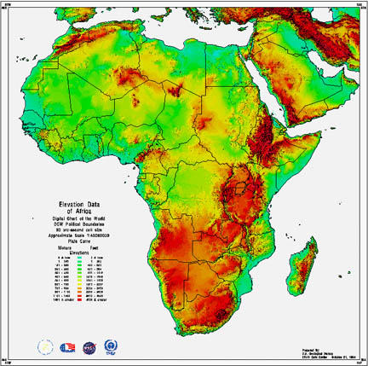

- The map above uses color (see shaded areas) to identify the height of landforms; it is called an

_____________________________

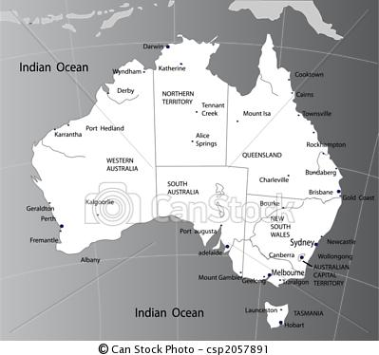

- The map above identifies capitals and other important cities; it is called a . . .

_____________________________

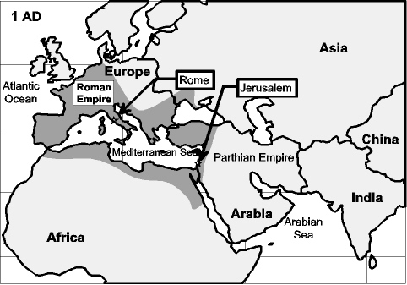

- The map above (see previous page) helps us understand the events that have shaped the lives of people over many years; it’s called a __________________________________

Part C: Mapping the Earth (5 points each)
- Directions: Insert the correct term from the box that best identifies the answer.
Map scale; intermediate directions; relative location; an aerial photograph; globe; map; cardinal directions

- I am the part of the map that helps you find the actual distance between two places; therefore, I must be the _______________________.

- I am the part of the map that describes one place in relation to another; therefore, I must be the __________________________.

- I am a satellite picture that enables you to see patterns on Earth’s surface; therefore, I must be ________________________.

- I am a round model of the Earth; therefore I must be a ____________________.

- I am flat representation of the Earth’s surface; therefore I must be a ________________.

Part D: Short Answers (5 points each)
- Directions: Answer the questions below to the best of your knowledge.

- What are the two most important characteristics of geography? ____________________________________________________________________________________________________________________________________________________________

- Give examples of physical geogrpahy and human geography in Ancient Greek culture. __________________________________________________________________________________________________________________________________________________________________________________________________________________________________________

- Which American cities witnessed terrorist acts on September 11, 2001? ____________________________________________________________________________________________________________________________________________________________

- Who was President on September 11, 2001? __________________________________________

PARENTAL ACKNOWLEDGMENT
Print Parent’s name: ____________________________________________________________________
Parent’s signature: _____________________________________________________________________
Date: ________________________________________________________________________________

NOTES/COMMENTS: ____________________________________________________________________
_____________________________________________________________________________________

